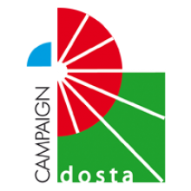
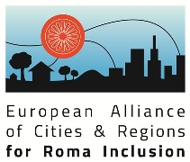
Congress/Dosta!-Prize
For Municipalities
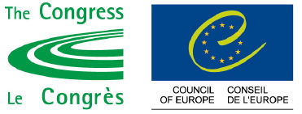

Application form

This form should be completed directly in your own word processor and sent back to the Council of Europe by mail or e-mail, at the latest by Tuesday, 30 June 2015.
Only the information specifically requested in the Application Form will be taken into account.
Proof of budgetary allocation must be appended to the application form, as well as proof of the active participation of the target Roma community (meeting reports, lists of participants, partnership agreements, etc.).

A – MUNICIPALITY INFORMATION
Municipality:
Region:

Country:
Contact person: Mr./Mrs.

Phone contact:
E-mail:
Address:

B – PROJECT INFORMATION
Title of the project:

Target group:

Implementation timeline (duration in month) :
Start date :
End date :

Project objective(s) (maximum 8 lines) :

Budget allocation :

- Percentage of general municipal budget :
- Grants from donors :
- Others :

NB: proof of budgetary allocation must be appended to the application form.

Please indicate which of the following criteria your project meets :
- Raise, directly or indirectly, public awareness on Roma rights and culture in order to combat stereotypes and prejudice toward Roma (through the media, educational systems and institutions, and local authorities);
- Improve the effective access of Roma to social and cultural rights (in particular through education);
- Promote intercultural and inter-ethnic dialogue;
- Promote diversity in community life;
- Promote active democratic participation;

C – DESCRIPTION OF THE PROJECT
Brief description of the project (maximum 12 lines) :

Working methods (maximum 12 lines) :

Outputs – which key indicators did you use to evaluate the project? (Please use quantitative data)

What measures are being taken to promote the project and its results?

What do you consider to be the transferable aspects of your project?

What aspects of your project are innovative?

Please list all materials and publications produced during the project, including audio-visual material if any (please enclose a copy of each item).

How do you ensure the sustainability of the project?

Council of Europe Christoph Stoeger Secretariat of the Alliance of Cities and Regions for Roma Inclusion Congress of local and regional authorities Council of Europe Tel.: +33 (0) 39021 5456 Email: congress.dosta-prize@coe.int

